M.Thanzil Ahamed – HND in QS &BE

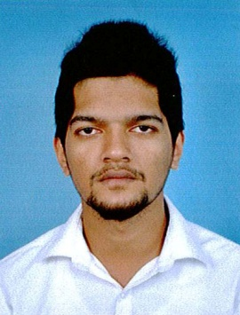  Contact Number:  +974 33940407  Email:  Ahamed110@gmail.com  Date of birth:  Dec 11th, 1992  Nationality:  Sri Lankan.  Civil Status:  Single  Language:  English, Tamil, Sinhala | Personal Profile  I am a well honest, hardworking, professional Quantity Surveyor having 2 years’ Experience in Tendering and Estimating. My prime objective is to attain a challenging position in the field of Quantity Surveying & Managing. And I have personal commitment to continuously increasing my knowledge.  Professional Qualification  Higher National Diploma in Quantity Surveying and Built Environment (Edexcel) at Srilanka Branch.  Modules Included:  - Design Principles and Applications  - Science and Materials  - Analytical Methods  - Management Principles and Application  - Group Project  - Health, Safety and Welfare  - Technology A  - Technology B  - Measurement A  - Site Surveying Procedures  - Contractual Procedures  - Tendering and Estimating  - Building Services Engineering Technology  - Measurement B  - Construction Economics  - Individual Student Project  - Work-Based Learning B  - IT Application-General  - IT Application-Computer Aided Design  - Communication Skills  Other Qualifications  - Successfully completed Advance Diploma in MEP Auto CAD at BICT.  - GCE Advanced Level (2011)  Work Experience  Assistant Quantity Surveyor  Coral Property Developers (January 2013 – June 2015)  POSITION HELD:  - Floating Enquiries / Obtaining Quotations / Price Comparison  - Taking-off Quantities  - Preparing Monthly Valuation  - Preparing / Evaluating Variation Orders and Valuation of Varied Works  - Inviting subcontractors and submitting the comparison report to the management.  - Identifying the variation between As- Tender & As- Built drawings & Specification, preparing claims according to the contract type (Lump-Sum, Re measurement or Design & Built...)  Computer Skills  References  I hereby certify that the details furnished above are true and accurate to the best of my knowledge.  M.Thanzil Ahamed Date: 8 November 2026
  Software Applications:  - MS word  - MS Excel  - MS Powerpoint | Construction & Technical Software:  AutoCAD
  Kavitha Srikandarajah,  Internal Lecturer,  ICBT Campus,  31&33, Hotel Road,  Mt Lavania,  Sri Lanka.  Off No: 0114210021 | I.M.Niyas,  Co-Operative Development Officer – Auditor,  ACCD Office,  Kalmunai,  Sri Lanka.  Telephone: 0752901805

